Lab 4 Test Case and Results

Contents

Black Box Testing 2

CreateNewJobInterface 2

Equivalence Partitioning & Boundary Value Analysis 2

Equivalence Partitioning 2

Boundary Value Analysis 3

Test Cases 3

White Box Testing 4

CreateNewRunner 4

Control Flow Graph 4

Basic Path Testing 5

Test Case 5

Complete Job 6

Control Flow Graph 6

Basic Path Testing 6

Test Case 7

References 7

# Black Box Testing

## CreateNewJobInterface

Control Class – CreateNewJobInterface

CreateNewJobinterface also serve is responsible for **Job Creation**. When the operator wants to create a new job to be added to the waiting list. The operator will first need to enter a valid ***postal code*** which will be verified with internal checks and OneMap API to ensure its validity. If it is found, the address and block number will be filled in where by the operator can then fill the remainder of the fields whenever appropriate.

## Equivalence Partitioning & Boundary Value Analysis

### Equivalence Partitioning

Equivalence Partitioning is a black box technique used by software testers to reduce the number of test cases while maintaining effective test coverage.

Valid Equivalence Class

* Valid Format (integer) -> Takes precedence over other validation
* Valid Digits -> Takes precedence over other validation except formatting
  + 6 Digits
* Valid Sectors Code (First 2 digits of postal code) (Singpost, 2024)
  + Continuous Value
  + 01 - 81
* Valid Delivery Point (Last 4 digits of postal code)
  + Discrete Values
  + If the block exists within the sector

Invalid Equivalence Class

* Invalid Format
  + Alphabets (a,A,h,H)
  + Special Characters (#, ! , ?)
* Invalid Digits
  + 0 to 5 digits, 7 to inf digits
* Invalid Sectors code
  + Discrete Value that does not have a sector associated to it
* Invalid Delivery Point
  + Block does not have a sector associated to it

### Boundary Value Analysis

Boundary Value Testing tests values at the boundary and is only applicable to continuous range of values. As the number of digits and sector code are digit and a range of digits on a continuous number line. We will take the edge values.

Invalid Digits

* Less than or equal 5, More than or equal to 7
* Boundary Values are 5 and 7

Invalid Sector Code

* Less than 01, More than 81
* Boundary Values are 00 and 82

## Test Cases

|  |  |  |  |  |  |
| --- | --- | --- | --- | --- | --- |
| Test No. | Test Input | Parameter | Expected Output | Actual Output | Success |
| 1 | Postal Code abcdef | Invalid Format (Characters) | Failed. Please key in a numerical postal code | Failed. Please key in a numerical postal code | True |
| 2 | Postal Code  57015! | Invalid Format (Special Characters) | Failed. Please key in a numerical postal code | Failed. Please key in a numerical postal code | True |
| 3 | Postal Code  57015 | Valid Format  Invalid Digits (Lower Bound) | Failed. Please key in a 6-digit postal code | Failed. Please key in a 6-digit postal code | True |
| 4 | Postal Code  8570157 | Valid Format  Invalid Digits (Upper Bound) | Failed. Please key in a 6-digit postal code | Failed. Please key in a 6-digit postal code | True |
| 5 | Postal Code  005780 | Valid Format  Valid Digits  Invalid Sector Code (Lower Bound) | Failed. Please key in a correct sector code | Failed. Please key in a correct sector code | True |
| 6 | Postal Code  829670 | Valid Format  Valid Digits  Invalid Sector Code (Upper Bound) | Failed. Please key in a correct sector code | Failed. Please key in a correct sector code | True |
| 7 | Postal Code  670356 | Valid Format  Valid Digits  Valid Sector Code  Invalid Delivery Point | Failed to find delivery point | Failed to find delivery point | True |
| 8 | Postal Code  639798 | Valid Format  Valid Digits  Valid Sector Code  Valid Delivery Point | Success | Success | True |

# White Box Testing

White box testing is the method used to test the software by developers. As such that 2 classes that will be tested are createnewrunner and completejob. The technique that will be used is Control Flow Testing.

## CreateNewRunner

### Control Flow Graph

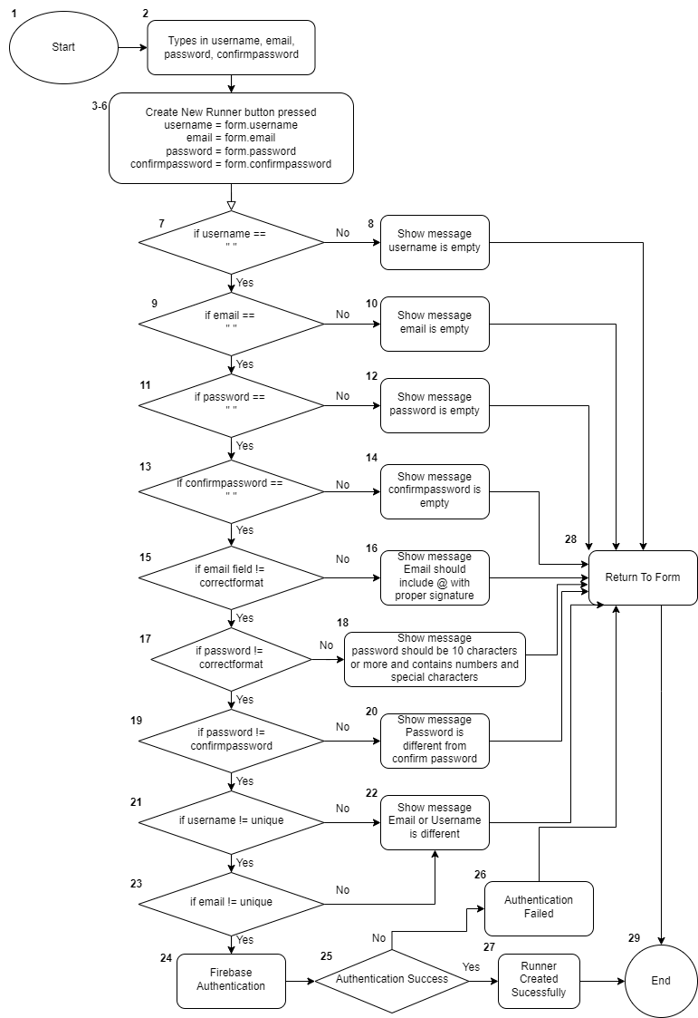

### Basic Path Testing

Level 3 – Basis Path Coverage

#### Cyclomatic Complexity

CC = | Decision Point + 1 | = 10 Decision Points + 1 = 11

#### Basis Paths

1. Baseline Path: 1-6,7,9,11,13,15,17,19,21,23,24,25,27,29
2. Basis Path 2: 1-6,7,8,28,29
3. Basis Path 3: 1-6,7,9,10,28,29
4. Basis Path 4: 1-6,7,9,11,12,28,29
5. Basis Path 5: 1-6,7,9,11,13,14,28,29
6. Basis Path 6: 1-6,7,9,11,13,15,16,28,29
7. Basis Path 7: 1-6,7,9,11,13,15,17,18,28,29
8. Basis Path 8: 1-6,7,9,11,13,15,17,19,20,28,29
9. Basis Path 9: 1-6,7,9,11,13,15,17,19,21,22,28,29
10. Basis Path 10: 1-6,7,9,11,13,15,17,19,21,23,22,28,29
11. Basis path 11: 1-6,7,9,11,13,15,17,19,21,23,24,25,26,28,29

### Test Case

|  |  |  |  |  |
| --- | --- | --- | --- | --- |
| Test No. | Condition | Expected Output | Actual Output | Success |
| 1 | Fields all correct | Runner Create Successfully | Runner Create Successfully | True |
| 2 | Username == Empty | Show message username is empty | Show message username is empty | True |
| 3 | Email == Empty | Show message email is empty | Show message email is empty | True |
| 4 | Password == Empty | Show message password is empty | Show message password is empty | True |
| 5 | ConfirmPassword == Empty | Show message confirmpassword is empty | Show message confirmpassword is empty | True |
| 6 | Email field == Incorrect | Show message  Email should include @ with proper signature | Show message  Email should include @ with proper signature | True |
| 7 | Password field == Incorrect | Show messagepassword should be 10 characters or more and contains numbers and special characters | Show message  password should be 10 characters or more and contains numbers and special characters | True |
| 8 | Password != ConfirmPassword | Show message  Password is different from confirm password | Show message  Password is different from confirm password | True |
| 9 | Username != Unique | Show message  Email or Username is different | Show message  Email or Username is different | True |
| 10 | Email != Unique | Show message  Email or Username is different | Show message  Email or Username is different | True |
| 11 | Authentication Failed | Show Authentication Failed | Show Authentication Failed | True |

## Complete Job

### Control Flow Graph

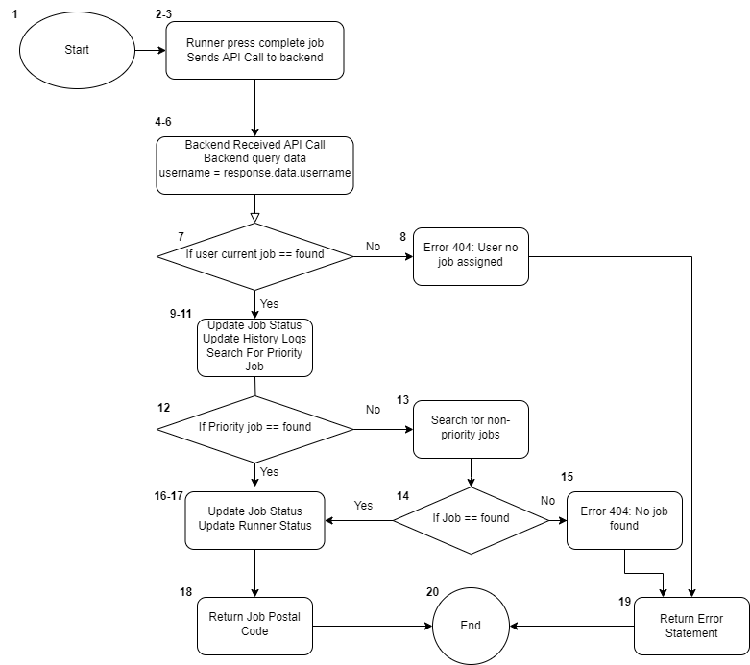

### Basic Path Testing

Level 3 – Basis Path Coverage

#### Cyclomatic Complexity

CC = | Decision Point + 1 | = 3 Decision Points + 1 = 4

#### Basis Paths

1. Baseline Path: 1-6,7,9-11,12,16-18,20
2. Basis Path 2: 1-6,7,8,19,20
3. Basis Path 3: 1-6,7,9-11,12,13,14,15,19,20
4. Basis Path 4: 1-6,7,9-11,12,13,14,16-18,20

### Test Case

|  |  |  |  |  |
| --- | --- | --- | --- | --- |
| Test No. | Parameters | Expected Output | Actual Output | Success |
| 1 | Current Job Found. Priority Job Found | Return Job Postal Code | Return Job Postal Code | True |
| 2 | Current Job not Found | Error 404: User no job assigned | Error 404: User no job assigned | True |
| 3 | Current Job Found, Priority Job Not Found, Job Not Found | Error 404: No job found | Error 404: No job found | True |
| 4 | Current Job Found, Priority job not found, Job Found | Return Job Postal Code | Return Job Postal Code | True |

# References

Singpost. (2024). *List of Postal Districts.* Retrieved from List of Postal Districts: https://www.ura.gov.sg/Corporate/-/media/Corporate/Property/PMI-Online/List_Of_Postal_Districts.pdf